**Lab worksheet 2: Numerical Data**

**CT/2021/055 – M.S.M.Althaf**

**Question: 01**

Code

package Q_01;  
import java.text.DecimalFormat;  
  
public class Question_01 {  
 public static void main(String[] args) {  
 int A = 2 , B = 4 , C = 6;  
 int X = 3 , Y = 5;  
 double a,b,c,d; // for answers  
 System.*out*.println("A=" + A + " B=" + B + " C=" + C + " X=" + X + " Y=" + Y);  
 DecimalFormat df = new DecimalFormat("0.00");  
  
 a = Math.*sqrt*((Math.*pow*(B,2)) + (4*A*C));  
 System.*out*.println("The square root of B^2 + 4AC : " + df.format(a));  
  
 b = Math.*sqrt*(X + (4 * Math.*pow*(Y,3)));  
 System.*out*.println("The square root of X + 4Y^3 : " + df.format(b));  
  
 double product = X*Y;  
 c = Math.*cbrt*(product);  
 System.*out*.println("The cube root of the product of X and Y :" + df.format(c));  
  
 final double PI = 3.14;  
 double Radius = 7;  
  
 d = PI*Radius*Radius;  
 System.*out*.println("Area of the circle : " + df.format(d));  
 }  
}

Output

**Question: 02**

Code

package Q_02;  
import java.text.DecimalFormat;  
import java.util.Scanner;  
  
public class Question_02 {  
 public static void main(String[] args) {  
 double cm,totalInches,in;  
 int ft;  
 Scanner Input = new Scanner(System.*in*);  
 System.*out*.print("Enter the value in centimeters : ");  
 cm = Input.nextDouble();  
  
 totalInches = cm / 2.54;  
 ft = (int) totalInches / 12;  
 in = totalInches - (ft * 12);  
  
 DecimalFormat df = new DecimalFormat("0.00");  
 System.*out*.println(cm + " Centimeters = " + ft + " feets and " + df.format(in) + " inches");  
  
 }  
}

Output

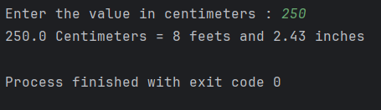

**Question: 03**

package Q_03;  
  
import java.util.Scanner;  
  
public class Question_03 {  
 public static void main(String[] args) {  
 double Celsius,Fahrenheit;  
 Scanner Input = new Scanner(System.*in*);  
 System.*out*.print("Enter the temperature in Celsius : ");  
 Celsius = Input.nextDouble();  
  
 Fahrenheit = (1.8 * Celsius) + 32;  
  
 System.*out*.println("Fahrenheit Value is : " + Fahrenheit);  
 }  
}

**Output**

**Question: 04**

package Q_04;  
  
import java.util.Scanner;  
  
public class Question_04 {  
 public static void main(String[] args) {  
 int bodyWeight,calories;  
 Scanner Input = new Scanner(System.*in*);  
 System.*out*.print("Enter the body weight in pounds : ");  
 bodyWeight = Input.nextInt();  
  
 calories = bodyWeight * 19;  
  
 System.*out*.println("You need " + calories + " calories in one day" );  
  
 }  
}

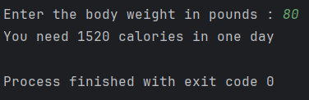**Output**

**Question: 05**

package Q_05;  
import java.util.Scanner;  
  
public class Question_05 {  
 public static void main(String[] args) {  
 double Celsius,Fahrenheit;  
 Scanner Input = new Scanner(System.*in*);  
 System.*out*.print("Enter the temperature in Fahrenheit : ");  
 Fahrenheit = Input.nextDouble();  
 Celsius = (5.0/9) * (Fahrenheit - 32);  
 System.*out*.println("Celsius Value is : " + Celsius);  
 }  
}

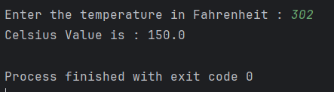

**Output**

**Question: 06**

package Q_06;  
  
import java.util.Scanner;  
import java.time.Year;  
  
public class Question_06 {  
 public static void main(String[] args) {  
 int birthYear,Age;  
 Scanner Input = new Scanner(System.*in*);  
 System.*out*.print("What is your birth year? : ");  
 birthYear = Input.nextInt();  
 int currentYear = Year.*now*().getValue();  
 //System.out.println("Current Year: " + currentYear);  
  
 Age = currentYear - birthYear;  
 System.*out*.println("You were born in "+birthYear+" and will be (are) "+ Age + " this year.");  
  
 }  
}

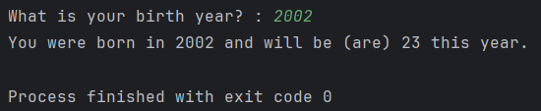

**Output**

**Question: 07**

package Q_07;  
  
import java.text.DecimalFormat;  
import java.util.Scanner;  
  
public class Question_07 {  
 public static void main(String[] args) {  
 double W,H,BMI;  
 Scanner Input = new Scanner(System.*in*);  
 System.*out*.print("Enter your weight in Kg : ");  
 W = Input.nextDouble();  
 System.*out*.print("Enter your height in cm : ");  
 H = Input.nextDouble();  
  
 BMI = W / Math.*pow*((H/100),2);  
 DecimalFormat df = new DecimalFormat("0.00");  
 System.*out*.println("BMI : " + df.format(BMI));  
 }  
}

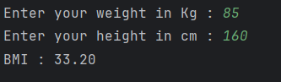**Output**

**Question: 08**

package Q_08;  
import java.text.DecimalFormat;  
import java.util.Scanner;  
  
public class Question_08 {  
 public static void main(String[] args) {  
 double R,V; // R - Radius V - Volume  
 final double PI = 3.14;  
 Scanner Input = new Scanner(System.*in*);  
 System.*out*.print("Enter the Radius : ");  
 R = Input.nextDouble();  
 V = (4/3.0) * (PI * Math.*pow*(R,3));  
 DecimalFormat df = new DecimalFormat("0.00");  
 System.*out*.println("Volume of a sphere is : " + df.format(V));  
 }  
}

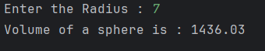**Output**

**Question: 09**

package Q_09;  
import java.text.DecimalFormat;  
import java.util.Scanner;  
  
public class Question_09 {  
 public static void main(String[] args) {  
 double P,R; // P - Invest amount in dollars R - Interest rate compounded annually  
 int N; // N - Number of years  
 double M; // Amount of money earned after N years

Scanner Input = new Scanner(System.*in*);  
 System.*out*.print("Enter the invest amount in dollars : ");  
 P = Input.nextDouble();

System.*out*.print("Enter interest rate compounded annually : ");  
 R = Input.nextDouble();

System.*out*.print("Enter the number of years : ");  
 N = Input.nextInt();

M = P * Math.*pow*((1+(R/100)),N);  
 DecimalFormat df = new DecimalFormat("0.00");

System.*out*.print("Amount of money earned after N years : " + df.format(M) + " $");  
 }  
}

**Output**

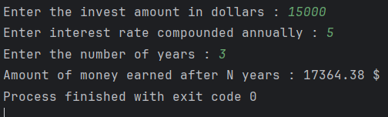

**Question: 10**

package Q_10;  
import java.text.DecimalFormat;  
import java.util.Scanner;  
  
public class Question_10 {  
 public static void main(String[] args) {  
 double loanAmount,annualInterestRate;  
 int loanPeriod;  
 final int MONTHS_IN_YEAR = 12;  
 Scanner Input = new Scanner(System.*in*);  
 System.*out*.print("Enter the Loan amount : ");  
 loanAmount = Input.nextDouble();  
  
 System.*out*.print("Enter the Annual interest rate : ");  
 annualInterestRate = Input.nextDouble();  
  
 System.*out*.print("Enter the loan period in years : ");  
 loanPeriod = Input.nextInt();  
  
 double monthlyInterestRate = annualInterestRate / 100.0 / MONTHS_IN_YEAR;  
 int numberOfPayments = loanPeriod * MONTHS_IN_YEAR;  
 double monthlyPayment = (loanAmount * monthlyInterestRate) / (1 - Math.*pow*(1/(1+monthlyInterestRate),numberOfPayments));  
 double totalPayment = monthlyPayment * numberOfPayments;  
  
 DecimalFormat df = new DecimalFormat("0.00");  
 System.*out*.println("Monthly Payment : " + df.format(monthlyPayment));  
 System.*out*.println("Total Payment : " + df.format(totalPayment));  
   
 }  
}

package Q_10;  
  
import java.util.Scanner;  
  
public class Odd_String {  
 public static void main(String[] args) {  
 Scanner Input = new Scanner(System.*in*);  
 System.*out*.print("Enter the string with number of odd characters:");  
 String Sentence = Input.nextLine();  
  
 int Length = Sentence.length();  
  
 int Index_of_Middle = (Length/2)+1;  
 System.*out*.println(Sentence.substring(Length/2,Index_of_Middle));  
 }  
}

**Output:**

